# **Potential problems in FPGA of Pizzabox (encoder)**

## Digital logic

### Filtering algorithm

The following problem may happen.

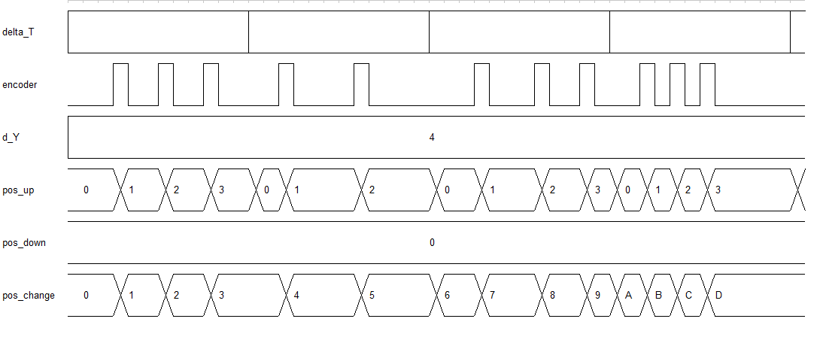

## Software program

### Shared memory in receiving

pscEpicsRx_thread creates new threads pscEpicsProcess_rx_request to process received data, which is stored in DDR3 at fixed address. If new packets are received before the old packet has not been processed, the old data could be overwritten.

* If this will never happen (arriving interval > processing time), process data in pscEpicsRx_thread directly. No new thread is necessary.
* If this will happen, use different memory space instead.

### Mac_addr_get (console_cmd.c)

len = **strlen**(data);

**if**( len < 15 && len > 17) // will never be True

The if() should be

**if**( len < 15 || len > 17)

### txHeadBuf (pscEpics_sock_tx.c)

txHeadBufis defined as a pointer pointing to a char array of 128. It is used to store message head. However, only 8 bytes (HEAD_SIZE) are used.

### Variables not initialized before being read

* Circular buffer registers (head, tail) , skip[5].